

**DIKO** User Guide

v1.0

©2017-2019 版权所有坐言起行教育有限公司。

**目录**

1 介绍 3

2 入门 4

3 Normal Function 7

3.1 View Folder and Document 7

**3.1.1** **Add/Edit/Delete Comment** 8

**3.1.2** **Add Cross-reference document** 8

3.2 Add Folder 9

3.3 Add Document 10日

3.4 Add Shortcut 12

3.5 Add New Version 14

3.6 View Document Version 17

3.7 Cut/Move/Copy 19

3.8 Delete Folder and document 22

3.9 Assign Permission 24

3.10 审计日志 28

3.11 下载文件 29

3.12 Check-out / Check-in Document (Lock/Unlock) 30

3.13 Send Link To Email 33

3.14 Generate Barcode Label 35

3.15 Properties 35

**3.15.1** **Folder Properties** 36

**3.15.2** **Document Properties** 38

**3.15.3** **Shortcut Properties** 40

4 Searching 41

4.1 Advance Search 42

**4.1.1** **Document Search** 42

**4.1.2** **Category Search** 42

**4.1.3** **Full Text Search** 43

5 系統功能 44

5.1 Change Personal Profile 44

# 介绍

**DIKO**是一个基于网络的知识管理系统，负责维护文件完整性并限制文件访问。“知识”来自我们用户的文件、会议议程、电子邮件和其他可能的知识来源。DIKO不仅可以作为用户分享他们“知识”的平台，而且还增强了公司内各用户之间的文件协作。**DIKO** provides a multilingual and intuitive user interface including English, Simplified and Traditional Chinese, to speed up the operation efficiency. This document provides an operation guideline on **DIKO.**

# 入门

To use **DIKO**, the user simply opens a web browser like Internet Explorer, Google Chrome or Apple Safari. **Enter DIKO URL,** Page will then redirect to DIKO login page. The Login screen of DIKO will show up as follow:

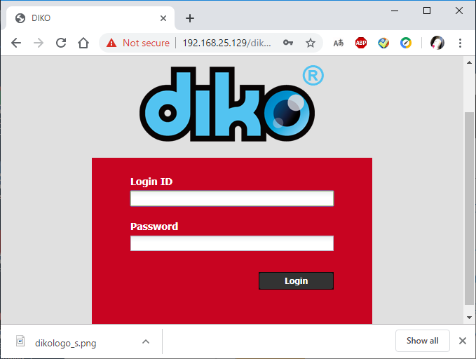

After entering the correct **Login ID** and **Password, DIKO** will grant the user to access the system and bring up the Main screen as follows:

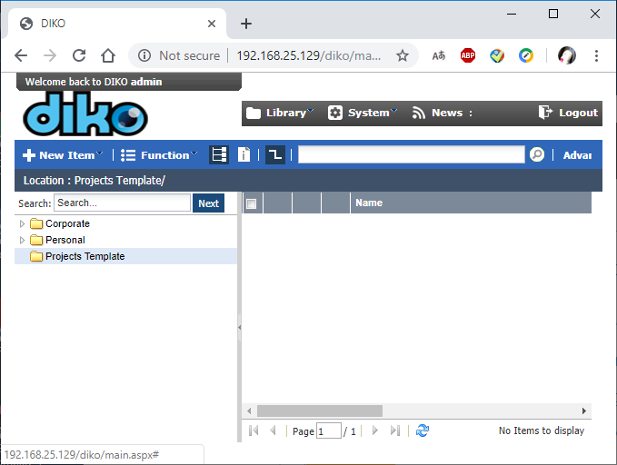

In **DIKO**, there are two working spaces for the users namely, **Corporate Library** and **Personal Library**. Every user has his/her own working space called **Personal Library** which cannot be accessed by other users including the System Administrator. The **Corporate Library**, on the other hand, can be accessed by all users in the section and it is governed by the assigned permissions. The initial draft of a document can be stored in the **Personal Library**. When it is done, the document can be moved to the **Corporate Library** for sharing. To switch between **Library**, click the button and choose the wanted **Library**.

There are four different kinds of Object in DIKO namely, **Folder**, **Document**, **URL** and **Shortcut**. The following table shows the usage of these Objects.

|  |  |
| --- | --- |
| Object Type | Description |
| Folder | A container to hold other objects in **DIKO**. |
| Document | A reference to a stored electronic file in **DIKO**. |
| URL | A link to a web site. |
| Shortcut | A reference to a Folder, Document or URL in **DIKO**. |

**Table 1 Objects Description**

The Main screen can be divided into three sections namely, **Menu** (top), **Tree-view** (left) and **Folder Content** (right). The **Menu** section contains access to the **Diko** functions. The **Tree-view** section shows the folder hierarchy in **Diko**. The **Folder Content** section lists the Objects in a selected folder.

To manage the object, simply right mouse-click the Object and a pop-up menu will show up. The number of functions shown in the pop-up menu depends on the Object type and permissions assigned to that Object. The following diagram shows the functions in the pop-up menu.

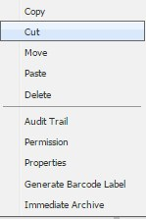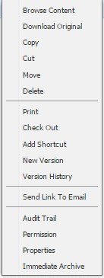

# Normal Function

## View Folder and Document

User must have **Browse Content** permission to view There are two ways to view the contents in a folder.

1. Double-clicking a folder name to enter the folder and list all its contents.
2. Click the folder in the Tree-view section and its contents will be shown on the **Folder Content** section.

There are two ways to view a document:

* 1. Double click the document name.
  2. Right mouse-click the document to bring up the pop-up menu and click the ***Browse Content*** function to view the document.

The following document viewing screen will be shown:

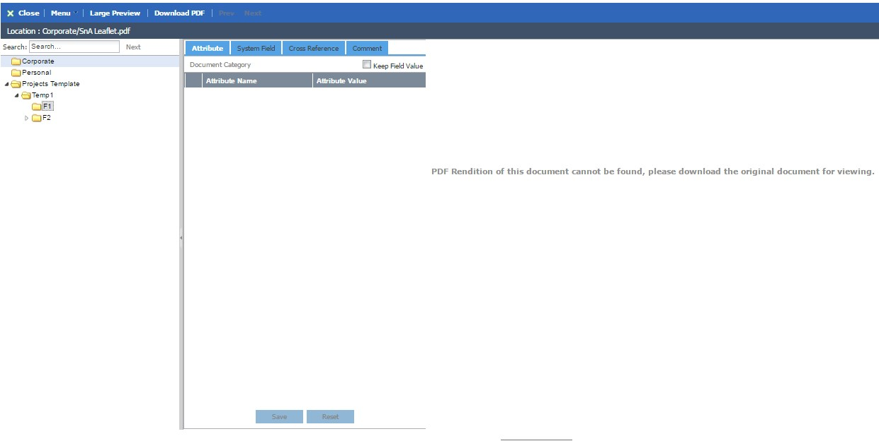

There are three panels in the Document Viewing screen. The left panel shows the tree-view of folder hierarchy. The middle panel shows the **Categories** of **Attributes** assigned to the document. The right panel shows the PDF rendition of the document.

### **Add/Edit/Delete Comment**

To add a comment of a viewing document:

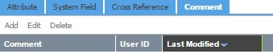

Click the ***Add*** function to bring up the screen as follows:

aClick to save the comment. Select the comment and click

***Edit/Delete***

to modify

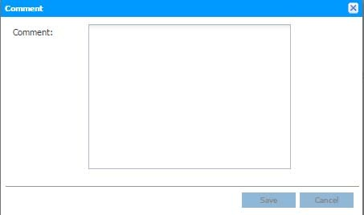

the comment or delete the comment.

### **Add Cross-reference document**

To add a cross-reference document of a viewing document, click the ***Add*** function

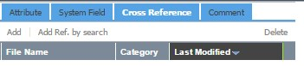

Add → Browse a file to add as reference.

Add Ref. by search →Search a document to add as reference.

## Add Folder

#### User must have **Add** permission to add folder

To add a folder in **Diko**, simply click the  button and select the ***New Folder*** function. The New Folder screen will be shown as follows:

Enter the folder name in the **Document Name** field. User may click choose a destination. Select the **Display Category**, the right panel is to control the display field and display order **(0 means will not be displayed; 1,2,3… means the display order)**. Click the  button to create the folder at the location specified in the **Folder** field. To cancel adding the folder, click the  button to exit the **New Folder** screen.

to

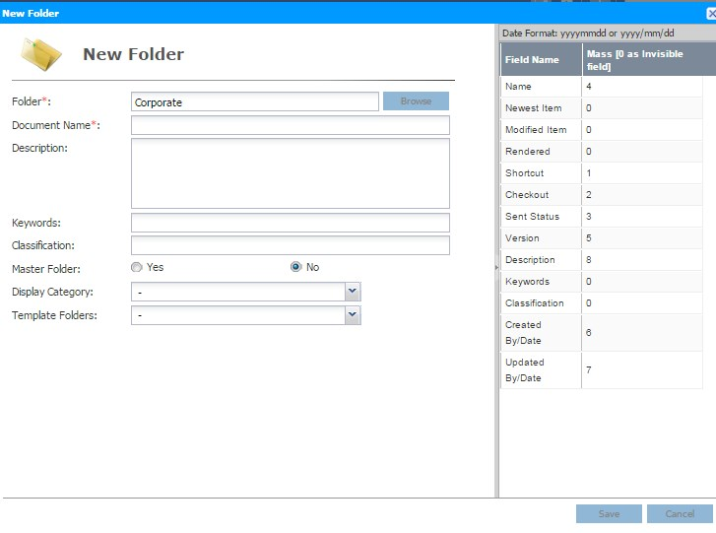

**New Folder** screen.

|  |  |
| --- | --- |
| Field Name | Description |
| Folder | Shows the location where the **Folder** will be created. |
| Document Name | The name of the new **Folder**. |
| Keywords | The keywords specified for the new **Folder**. This field can be blanked. |
| Classification | The classification specified for the new **Folder**. This field can be blanked. |
| Description | The description specified for the new **Folder**. This field can be blanked. |
| Master Folder | Specify whether this folder is master folder. |
| Display Category | Select the category and display its attributes. |
| Template Folder | User in ‘Project Folder Creation’ group can select template to create folder. |

**Table 2 Add Folder field description**

## Add Document

#### User must have **Add** permission to add document

To add a folder in **Diko**, simply click the  button and select the ***New Document*** function. The **New Document** screen will be shown as follows:

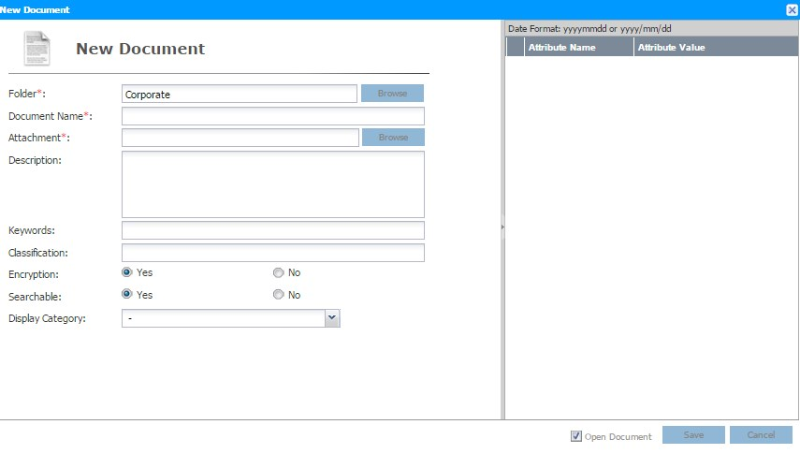

The **Folder** button is to select an upload destination of **Diko**. The

**Attachment** button is to select a document from local workstation. The

**Display Category** is inherited from the parent folder. Users may change this category.

The right panel is for user to enter the attribute of this document. Click the  button to upload the document to the location specified in the **Folder** field. When a document is added, a PDF rendition of the document will be created for display. **Diko** supports more than 40 different types of office documents for PDF rendition.

To cancel adding the document, click the  button to exit the **New Document** screen.

**New Document** screen.

|  |  |
| --- | --- |
| Field Name | Description |
| Folder | Shows the location where the **Document** will be created. |
| Document Name | The name of the new **Document**. |
| Attachment | The selected electronic file from the local workstation. |
| Keywords | The keywords specified for the new **Document**. This field can be blanked. |
| Classification | The classification specified for the new **Document**. This field can be blanked. |
| Description | The description specified for the new **Document**. This field can be blanked. |
| Encryption | Specify whether the document will be encrypted on the file system or not. **If Yes, the file stored on the diko Server file system will be encrypted using AES 256-bit encryption. If No, the file will be stored in its native format. This should choose the default setting Yes.** |
| Searchable | Specify whether the document can be searched. |
| Display Category | Select the category and display its attributes. |

**Table 3 Add Document field description**

## Add Shortcut

#### User must have **ADD** permission to add shortcut

**Shortcut** provides a quick access to the Diko Document or URL. To add a **Shortcut**, click the  button and select the ***New Shortcut*** function. The **New Shortcut** screen will be shown as follows:

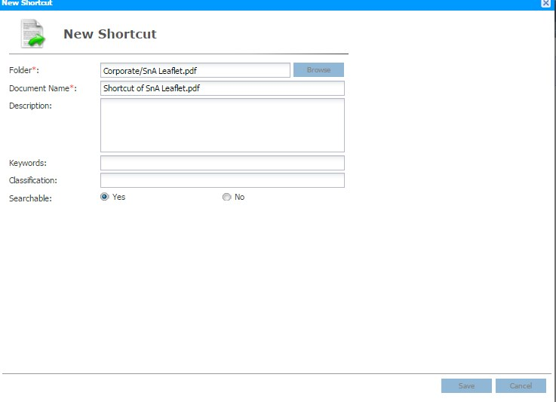

Enter the **Shortcut** name in the **Document Name** field and click the **Target**

button to select the reference Object. Click the button to create the **Shortcut**. To cancel adding the **Shortcut**, click the button to exit the **New Shortcut** screen.



**New Shortcut** screen.

|  |  |
| --- | --- |
| Field Name | Description |
| Document Name | The name of the new **Shortcut**. |
| Target | The reference to the Diko Object. |
| Keywords | The keywords specified for the new **Shortcut**. This field can be blanked. |
| Classification | The classification specified for the new **Shortcut**. This field can be blanked. |
| Description | The description specified for the new **Shortcut**. This field can be blanked. |

**Table 4 Add Shortcut field description**

## Add New Version

#### User must have **Add** permission to add version

To add a new version to an existing document, right mouse-click the document in the main panel to bring up the pop-up menu and click the ***New Version*** function.

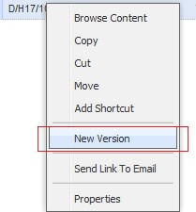

The **New Version** screen will be shown as follows:

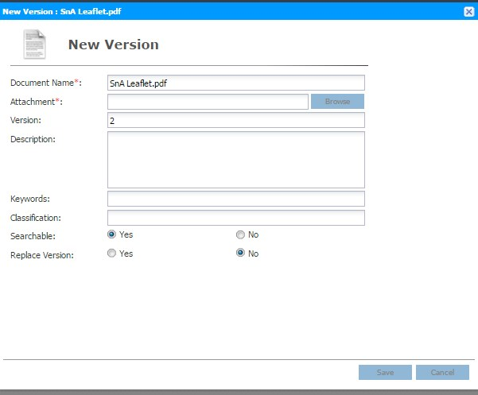

Just simple click **Attachment**button to select a document from local

workstation, and choose to replace version or not. Click the button to create version. To cancel new version, click the  button to exit the **New Version** screen.

The following table describes the fields in the **New Version** screen.

|  |  |
| --- | --- |
| Field Name | Description |
| Document Name | The name of the new document. |
| Attachment | The selected electronic file from the local workstation. |
| 版本 | The new version number of the document. |
| Keywords | The keywords specified for the new document version. This field can be blanked. |
| Classification | The classification specified for the new document version. This field can be blanked. |
| Description | The description specified for the new document version. This field can be blanked. |
| Searchable | Specify whether the document can be searched. |
| Replace Version | Determine whether the new document version will be replaced the existing document version. **If Yes, the new document version will be replaced. If No, the new document version will be added without deleting the existing document version**. |

**Table 5 Add Version field description**

## View Document Version

#### User must have **Version History** permission to view document version

To view previous version of a document, right mouse-click a document to bring up the pop-up menu and click the ***Version History*** function.

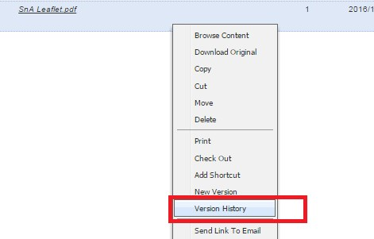

The **Version History** screen will be shown up as follows:

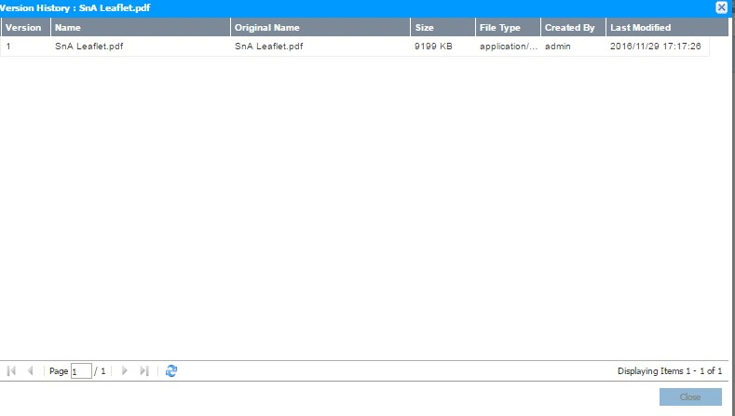

The **Version History** screen lists all versions of the selected document. To view any one of the versions, double-click one of the entries to view the document content.

## Cut/Move/Copy

User must have **Copy** permission to enable *Cut/Move/Copy* options, and have **Add** permission on the destination folder to enable *Paste* option 2 ways To ***Move*** item:

1. Use the mouse to drag item(s) to the new location in the Tree-view section. A confirmation message will be shown

Click the button to confirm the move or the  button to cancel The move.

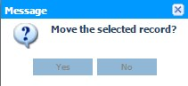

1. Right mouse-click an item in the main panel to bring up the pop-up menuand click

>Move.

the

***Move***

function OR multi-select items and click

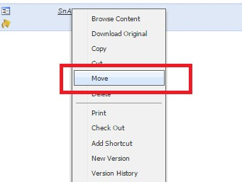

A Screen will pop up to browse a destination to move.

Click the cancel.

button to confirm the movement or the

button to

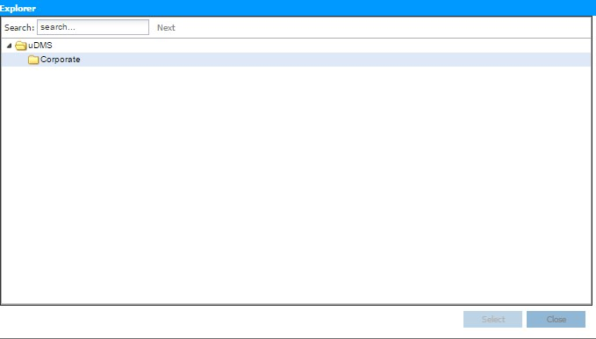

To ***Cut and Paste*** an item:

1. Right mouse-click an item in the main panel to bring up the pop-up menu and click the ***Cut*** function.

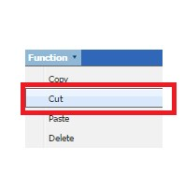

Right mouse-click the new location to bring up the pop-up menu and click the ***Paste*** function to move the item to the new location.

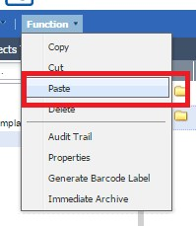

To ***Copy and Paste*** an item:

Right mouse-click an item in the main panel to bring up the pop-up menu and click the ***Copy*** function.

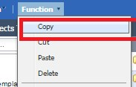

Right mouse-click the new location to bring up the pop-up menu and click the ***Paste*** function to move the item to the new location.

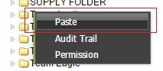

## Delete Folder and document

#### User must have **Delete** permission

To delete, right mouse-click a folder/document in the main panel to bring up the pop-up menu and click the ***Delete*** function OR multi-select items and click > Delete.

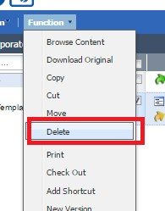

A confirmation message will be shown to prompt the user to confirm the deletion.

Click the button to confirm the deletion or the  button to cancel the deletion.

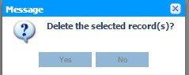

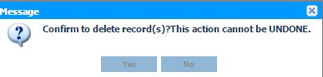

A confirmation will be promoted to confirm delete record. Click the  button to confirm the deletion or the  button to cancel the deletion.

## Assign Permission

#### User must have **Permission** to assign permission

To assign permissions, right mouse-click an item to bring up the pop-up menu and click the ***Permission*** function.

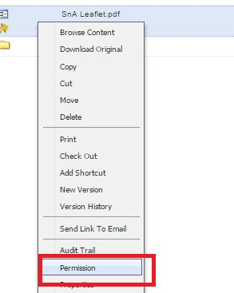

The **Permission** screen will be shown as follows:

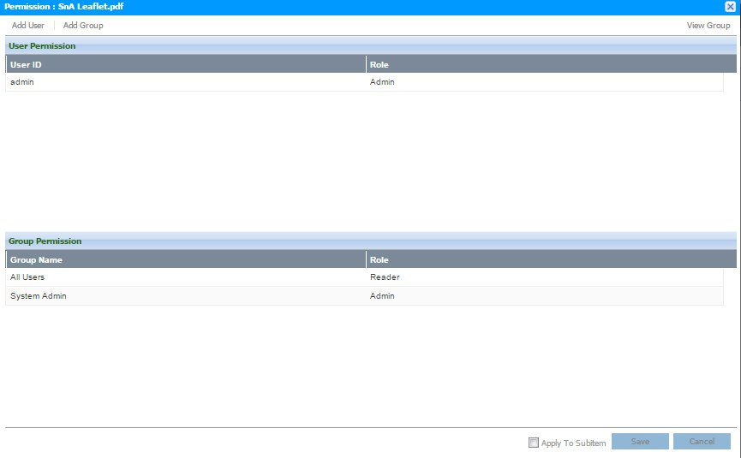

The top section of the **Permission** screen shows the permissions assigned to **User**. The bottom section of the **Permission** screen shows the permissions assigned to **Group**. If user wants to apply the current folder permissions to all of its content, tick the

checkbox. To assign permissions to Users or Groups, click the button from the top-left corner. A form will pop up to choose the user

or



or group for permissions assignment. The following table shows the interface after click ***Add User*** (***Add Group*** is similar).

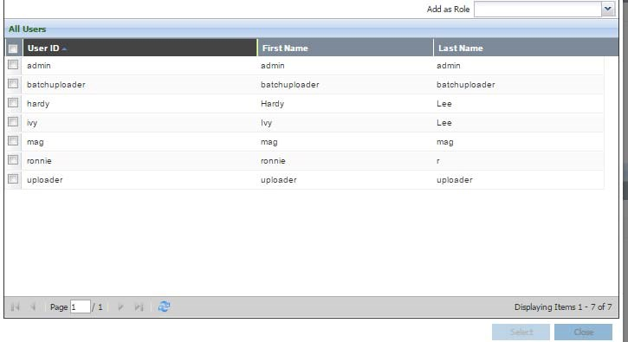

Select on the user and select the role through  and then click , it will go back to the permission screen.

Click the  button to apply the permissions setting. To exit the Permission screen,

click the  button.

About Roles:

**Reader, Editor, Admin** are system preset Roles.

**Admin** – granted all permission for user/group. User/Group which is assigned with this role can access all the function.

**Reader** – granted ***Browse*** permission for user/group. User/Group which is assigned with this role can only ***Browse*** folders/documents.

**Editor** - granted all permission **except *Assign Permission*** for user/group. User/Group which is assigned with this role can access all the function **except *Assign Permission***.

## 审计日志

#### User must have **Audit Trail** permission to view audit trail

To know what happened to an item, right mouse-click an item to bring up the pop-up menu and click the ***Audit Trail*** function.

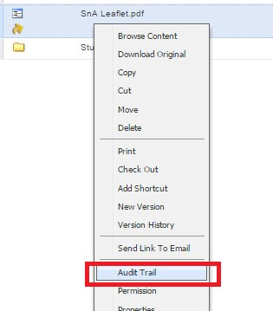

The **Audit Trail** screen will be shown as follows:

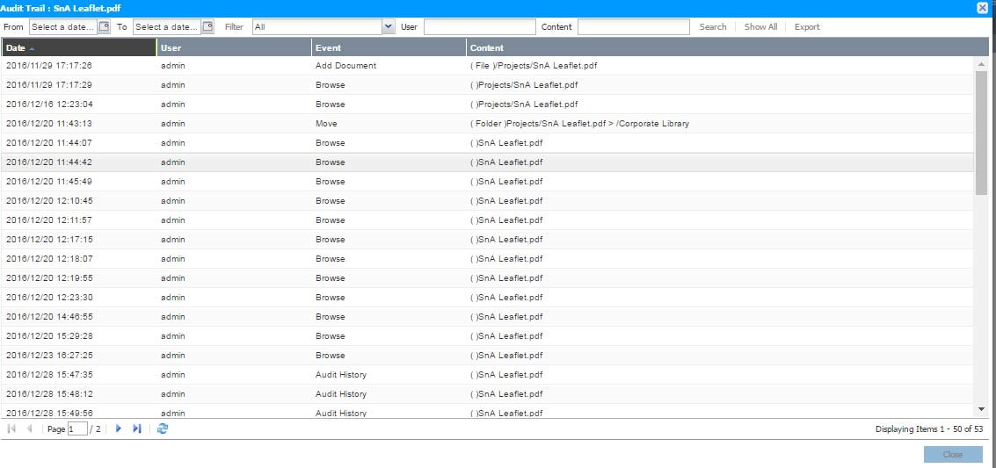

The Audit Trail screen lists every activity occurred on this item since its creation. To specify the criteria, user may:

Select the period through 

Specify the activity through 

Enter User involved through 

Enter Content through 

click the  button to list the specified activities. Click the  button to list all activities. **These activities cannot be deleted from diko by any users. These records are keeping in the system.** To keep a copy of the audit trail, click the  button will save the activities in an Excel file to the local workstation.

## 下载文件

User must have **Download** permission to download document.

To download the original document but not its PDF rendition, right mouse-click the document to bring up the pop-up menu and click the ***Download Original*** function.

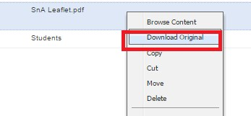

The document will be downloaded automatically.

## Check-out / Check-in Document (Lock/Unlock)

#### User must have **Check-Out** permission

To lock a document to avoid any changes made by others, right mouse click the document to bring up the pop-up menu and click the ***Check Out*** function.

will be shown next to the document (hover to show who locks the document).

A lock

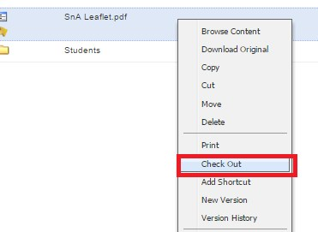

User has 2 options of check-in:

1. To unlock the document without making any changes, right mouse-click the document to bring up the pop-up menu and click the ***Check In*** function will unlock the document.

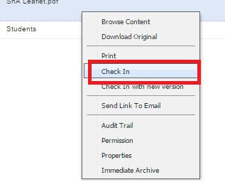

2.

3. To unlock the document with a new version, right mouse-click the document to bring up the pop-up menu and click the ***Check In with New Version*** function.

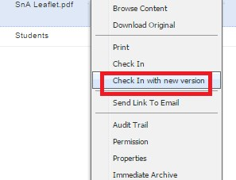

The following **Check In with New Version** screen will be shown:

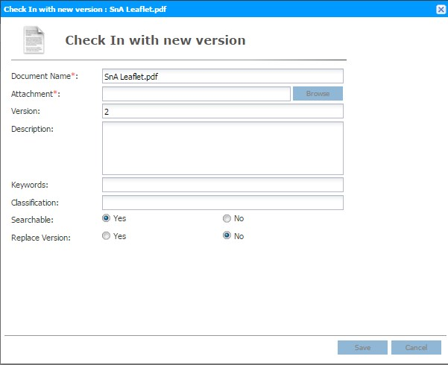

Click the **Attachment** button to select a file from the local workstation and click the  button to upload the document. The lock will be removed and a new version of the document is created. Click the to exit the screen.

The following table describes the fields in the **Check In with New Version** screen.

|  |  |
| --- | --- |
| Field | Description |
| Document Name | The name of the **Document**. |
| Attachment | The file from the local workstation. |
| 版本 | The version number of the **Document**. |
| Keywords | The keywords specified for the **Document**. This field can be blanked. |
| Classification | The classification specified for the **Document**. This field can be blanked. |
| Description | The description specified for the **Document**. This field can be blanked. |
| Searchable | Specify whether the document can be searched. |
| Replace Version | Determine whether the new **Document** version will be replaced the existing document version. **If Yes, the new document version will be replaced. If No, the new document version will be added without deleting the existing document version.** |

**Table 6 Check-In with new version field description**

## Send Link To Email

User may send the document link to other user by email. To access this function, right click the document to bring up pop-up menu, click ***Send Link To Email*** function.

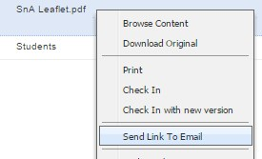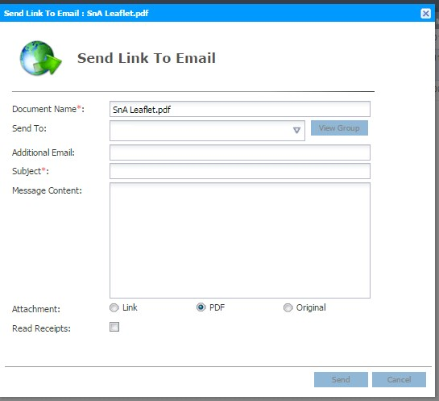

The following table shows the **Send link to email** field description:

|  |  |
| --- | --- |
| Field | Description |
| Document Name | The name of the **Document**. |
| Send To | The user which is existing in Diko. |
| Additional Email | Other receivers outside of Diko. |
| Subject | The subject of the email. |
| Message Content | The content of the email. |
| Attachment | Link – send the Diko link, link must be login to view document.  PDF – send the PDF to the receiver.  Original – send the Original Copy to the receiver. |
| Read Receipts | Specify to receive the read receipt. |

**Table7 Send link to email field description**

## Generate Barcode Label

To generate the barcode of the **folder**, select the **folder** and click the **Generate *Barcode Label*** function in the **Functions** menu. An image page containing the folder barcode will be generated and shown a new tab of the web browser. The barcode image can be printed. Note that each folder has a unique barcode value and the documents can be accurately filed depending on the barcode value. Moreover, category can be defined in any folder level.

## Properties

#### User must have **Update** permission to view Properties

To view the properties, right mouse-click to bring up the pop-up menu and click the ***Properties*** function.

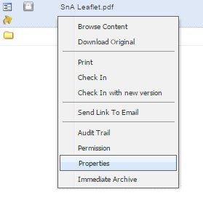

### **Folder Properties**

The following screen will be shown:

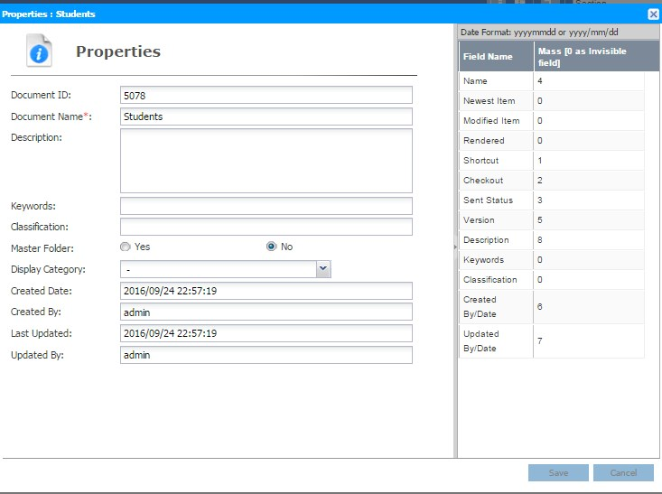

The **Display Category** will show the category when this folder was first created. The right panel is to control the display field and display order **(0 means will not be displayed; 1,2,3… means the display order)**.Click the button to save the updated properties or click the  button to exit the screen.

The following table describes the fields in the **Folder Properties** screen.

|  |  |
| --- | --- |
| Field | Description |
| Document ID | The ID of the **Folder**. |
| Document Name | The name of the **Folder**. |
| Keywords | The keywords assigned to the **Folder**. This field can be blanked. |
| Classification | The classification assigned to the **Folder**. This field can be blanked. |
| Description | The description assigned to the **Folder**. This field can be blanked. |
| Searchable | Specify whether the document can be searched. |
| Master Folder | Specify whether this folder is master folder. |
| Display Category | Select the category and display its attributes. |
| Created Date | The date and time when the **Folder** was created. |
| Created By | The user who created the **Folder**. |
| Last Updated | The date and time when the **Folder** was lastly modified. |
| Updated By | The user who lastly modified the **Folder**. |

**Table 8 Folder Properties field description**

### **Document Properties**

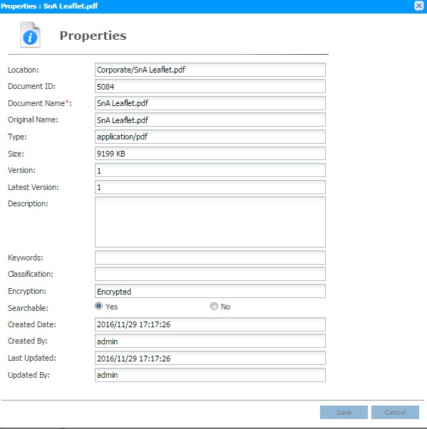

Click the button to save the updated properties or click the  button to exit the screen.

The following table describes the fields in the **Document Properties** screen.

|  |  |
| --- | --- |
| Field | Description |
| 地点 | The location where the **Document** resides in. |
| Document ID | The ID of the **Document**. |
| Document Name | The name of the **Document**. |
| Original Name | The name of the Original **Document**. |
| Type | The type of the Original **Document**. |
| Size | The size of the Original **Document**. |
| 版本 | The version of the **Document**. |
| Latest Version | The last version number of the **Document**. |
| Keywords | The keywords assigned to the **Document**. This field can be blanked. |
| Classification | The classification assigned to the **Document**. This field can be blanked. |
| Description | The description assigned to the **Document**. This field can be blanked. |
| Encryption | States whether encryption has applied to the **Document** or not. |
| Searchable | Specify whether the **Document** can be searched. |
| Created Date | The date and time when the **Document** was created. |
| Created By | The user who created the **Document**. |
| Last Updated | The date and time when the **Document** was lastly modified. |
| Updated By | The user who lastly modified the **Document**. |

**Table 9 Document Properties field description**

### **Shortcut Properties**

Click the button to save the updated properties or click the

button to exit

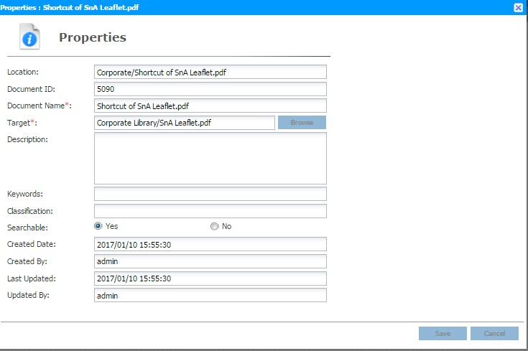

the screen.

The following table describes the fields in the **Shortcut Properties** screen.

|  |  |
| --- | --- |
| Field | Description |
| 地点 | The location where the **Shortcut** resides in. |
| Document ID | The ID of the **Shortcut**. |
| Document Name | The name of the **Shortcut**. |
| Target | The target of this **Shortcut** is pointing to. |
| Keywords | The keywords assigned to the **Shortcut**. This field can be blanked. |
| Classification | The classification assigned to the **Shortcut**. This field can be blanked. |
| Description | The description assigned to the **Shortcut**. This field can be blanked. |
| Searchable | Specify whether the **Shortcut** can be searched. |
| Created Date | The date and time when the **Shortcut** was created. |
| Created By | The user who created the **Shortcut**. |
| Last Updated | The date and time when the **Shortcut** was lastly modified. |
| Updated By | The user who lastly modified the **Shortcut**. |

**Table 10 Shortcut Properties field description**

# Searching

**Diko** supports both keyword and content search. Simply enter the searching term in the

Search bar and click theto start searching. The searching scope starts from the folder which the user is current at and throughout its siblings. The result will be displayed in the Search Result screen.

**To search exact match of keyword, use double quote (“”) to quote the keyword Example1:**



**It will search all items which contain Section A keyword.**

**Example2:**

**q**



**These symbols will look as Space: slash(/) hyphen(-) comma(,) ,it will search all results which contain Section *OR* A**

**Example 3:**



**Star(*) means any words. This example will search all items with any words after**

**Section such as Section A, Section123**

## Advance Search

A more specific search can be done in **Advance Search** screen. There are 3 tabs of search: **Document Search**, **Category Search** and **Full Text Search**. Click the

 button to access the advance searching function.

### **Document Search**

This searching screen allows users to find documents by its properties. Fill in the criteria and browse a **Destination** (leave the **Destination** blanked to search all available

directories in Corporate Library for the user). Click

under the tab to clear.

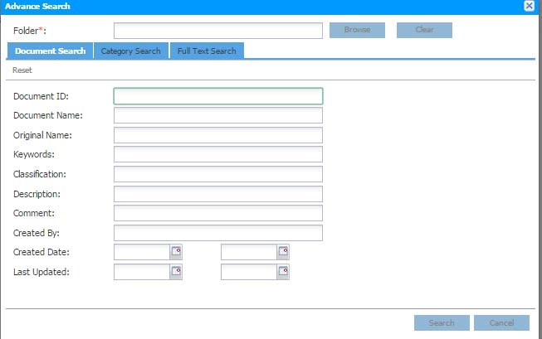

### **Category Search**

This screen allows you to specify one of the Categories to find documents.

Select the category through . Fill in the criteria

and browse a **Destination** (leave the **Destination** blanked to search all available

directories in Corporate Library for the user). Click  under the tab to clear fields.

For the **DATE** data type attribute, user may choose date from specific date to a specific date

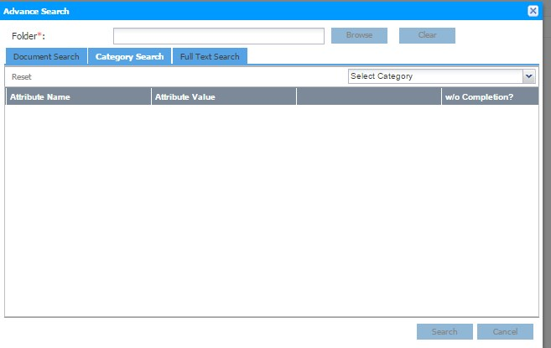

### **Full Text Search**

This screen allows users to find documents through the document content. **It is reminded that the result may not be found because the OCR text layer of PDF may not actually match the word you read.**

Fill in the criteria and browse a **Destination** (leave the **Destination** blanked to search all

available directories in Corporate Library for the user). Click  under the tab to clear fields.

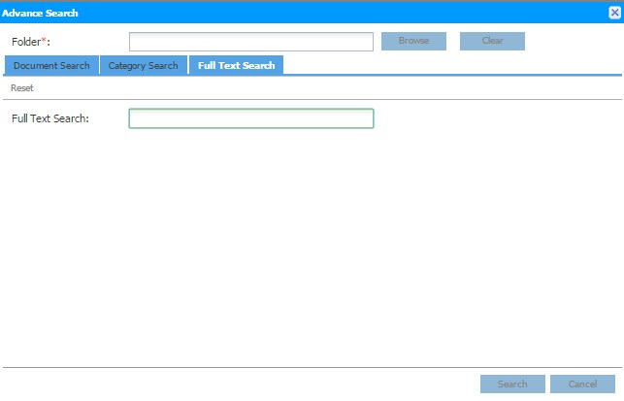

# 系統功能

## Change Personal Profile

Every user can change their own profile settings to meet his/her own needs. To change the Personal Profile, click the  button on the **Menu** section and click the ***Personal Profile*** function and the following screen will show:

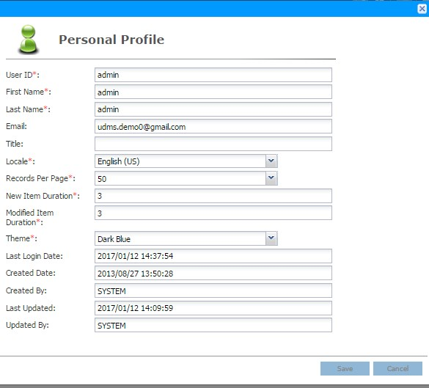

After making the changes, click the to save the profile or click the  button to exit the screen.

The following table describes the fields in the **Personal Profile** screen.

|  |  |
| --- | --- |
| Field | Description |
| User ID | The unique Login ID for the user. |
| First Name | The first name of the user. |
| Last Name | The last name of the user. |
| Email | The email address of the user. |
| Title | The title of the user. This field can be blanked. |
| Locale | The language for the User Interface. It can be “**English**”,  “**Japanese**”, “**Simplified Chinese**” or “**Traditional Chinese**”. |
| Records Per Page | The number of records shown on each page. The value ranges from **10** to **60**. |
| New Item Duration | Specify the number of days to classify the Object as “New”.  An icon  indicates the Object is newly created. |
| Modified Item Duration | Specify the number of days to classify the Object as “Modified”. An icon  indicates the Object is modified. |
| Theme | The color theme used for the User Interface. It can be “**Evergreen**”, “**Light Blue**”, “**Dark Metal**”, "**Dark Red**","**Dark Blue**" or "**Dark Green**". |
| Last Login Date | The date and time when the user lastly accessing the system. |
| Created Date | The date and time when the user was created |
| Created By | The user who created this user profile. |
| Last Updated | The date and time when the user profile was modified. |
| Updated By | The user who updated this user profile. |

**Table 11 Personal Profile field description 5.2 Change Password**

To change the password, click the  button on the **Menu** section and click the ***Change Password*** function and the following screen will show:

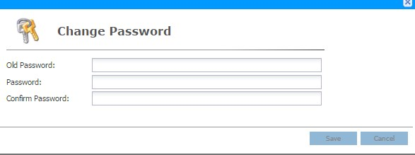

Enter the existing password in the “**Old Password**” field, enter the new password in both “**Password**” and “**Confirm Password**” fields and click the button to save the changes. Click the button to exit the screen.

The following table describes the fields in the **Change Password** screen.

|  |  |
| --- | --- |
| Field | Description |
| Old Password | The existing password. |
| 密码 | The new password. |
| Confirm Password | Re-type the new password. |

**Table 12 Change Password field description**